Medical Physics: Magnetic Resonance Imaging & Simulations

Marc Parcerisa i Conesa

May 2025

# BASES OF MAGNETIC RESONANCE

Magnetic resonance, commonly known as magnetic resonance imaging or MRI, is a non-invasive and non-ionizing imaging modality that provides detailed information about the anatomy, physiology, and pathology of various tissues and organs. That’s why it’s widely used in medicine for all kinds of purposes.

At its core, magnetic resonance relies on the behavior of the atomic nuclei that contain an odd number of protons or neutrons, as they will have, at their ground level, a spin value equal to ½. The most commonly used nuclei for clinical MRI are hydrogen nuclei or protons, due to their abundance in the human body. When placed in a strong magnetic field, such as the one generated by the MRI scanner, the protons align either with or against the field, resulting in a slight energy difference between the two spin states. Then, MRIs will manipulate these spin states and superposing different magnetic fields and RF pulses.

After applying a static magnetic field across the studied object, RF pulses at a specific frequency, known as the Larmor frequency, are generated. By tuning those pulses to the Larmor frequency of hydrogen (in most cases), resonance occurs, leading to the absorption of energy by the protons. When the RF pulse is turned off, the protons release this absorbed energy, which can be detected and measured. The Larmor frequency reads as follows:

Where depends on the type of resonator in use during the scan. In the case of hydrogen, these tend to be between 43 and 170 MHz. By manipulating the timing and duration of these pulses and/or magnetic field gradients, different types of image contrast can be achieved, highlighting variations in tissue properties such as water content, fat content, and molecular motion. Finally, an antenna will capture the released energy in form of electromagnetic pulses, and will register it, allowing for the reconstruction program to create 3D images of the patient.

# BASES OF MONTE CARLO SIMULATIONS

These are simulation techniques that are based on random sampling to model and analyze complex systems or processes. They involve generating multiple random samples or "trials" to estimate the behavior and outcomes of a system statistically.

In the context of an MRI scan, a Monte Carlo simulation can be employed to model and simulate the interactions of the magnetic fields and radiofrequency (RF) pulses with the human body. This simulation aims to predict the behavior of protons within the body and the resulting magnetic resonance signals that are detected by the MRI scanner. To make a simulation of an MRI scan, several factors need to be considered, including the strength of the magnetic fields, the timing and characteristics of the RF pulses, the relaxation properties of the materials, etc.

In this example, we were given a preset virtual representation of a brain and its tissue properties, such as proton density and relaxation times (T1 and T2), as well as an already programmed system for simulating what an MRI machine would do. By changing a few parameters in the simulation files, we were able to experiment with its behavior, such as (the simplest, really) the sum of accepted weights, the detection count.

# SIMULATION

With that, let us present our first simulation results:

|  |  |  |  |  |
| --- | --- | --- | --- | --- |
| **Collimator** | **Duration** | **History Count** | **Sum of Weights** | **Sum of Squared Weights** |
| Parallel | 10 | 1000000 |  |  |

Given that we want to have a count of , we’ll need to change the duration of the simulation by a factor of 22. With this new parameter set, the following parameters were obtained:

|  |  |  |  |  |
| --- | --- | --- | --- | --- |
| **Collimator** | **Duration** | **History Count** | **Sum of Weights** | **Sum of Squared Weights** |
| Parallel | 220 | 1000000 |  |  |

However, given that we want the least amount of variance on our simulations, the history count had to be changed as well so the sum of squared weights resembled the most to the sum of weights. It had to be multiplied by a factor of ~207:

|  |  |  |  |  |
| --- | --- | --- | --- | --- |
| **Collimator** | **Duration** | **History Count** | **Sum of Weights** | **Sum of Squared Weights** |
| Parallel | 220 | 207244723 |  |  |

With the simulation ended, it was time for the reconstruction.

# RECONSTRUCTION

The following data was obtained from the simulation:

|  |  |
| --- | --- |
| SINOGRAM   | PROJECTIONS |

Having the sinogram, a premade program was used to reconstruct the brain scan. However, three parameters can be set to change the outcome: The photons to be counted for the reconstruction (primary or total), the cut frequency for the Butterworth filter, and the exponent for the Butterworth filter. The last of those was set constant throughout the rest of the study, at a value of 5.2.

In contrast, six values for the cut frequency were studied for each of the primary and total photons. Here are the results:

|  |  |  |
| --- | --- | --- |
| **Cutoff** | **PRIMARY PHOTONS** | **TOTAL PHOTONS** |
| 0.02 |  |  |
| 0.1 |  |  |
| 0.3 |  |  |
| 0.5 |  |  |
| 0.7 |  |  |
| 0.9 |  |  |

# RECUPERATION COEFFICIENT

Using a third program, one can study how the recuperation coefficient changes depending on the cutoff frequency:

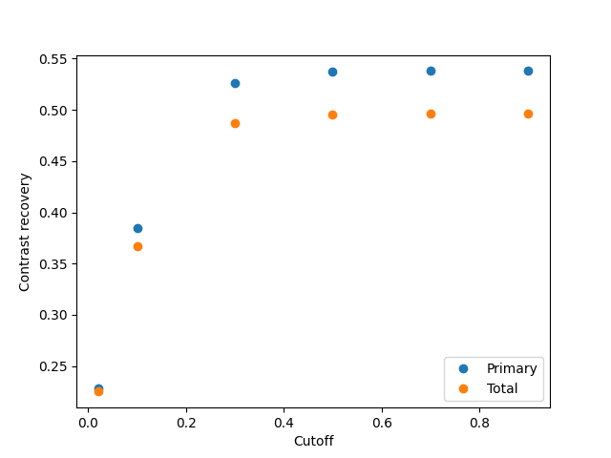

One can observe that the maximum contrast for the images is reached without the need for setting the cutoff frequency too high. This happens with both the primary photons and the total photons. Maximum contrast is reached roughly at frequency cutoff 0.5 for both modalities.

# CONCLUSIONS

In conclusion, the conducted Monte Carlo simulations provided valuable insights into the behavior of the simulated MRI system when various parameters were modified. By adjusting the duration and history count, we were able to achieve the desired results and optimize the simulation outcomes. Additionally, by exploring different cutoff frequencies for the reconstruction process, we observed that a cutoff frequency of 0.7 yielded maximum image contrast for both primary and total photons. These findings highlight the importance of parameter optimization in obtaining high-quality reconstructed images.